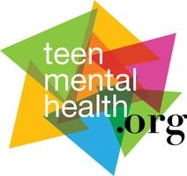
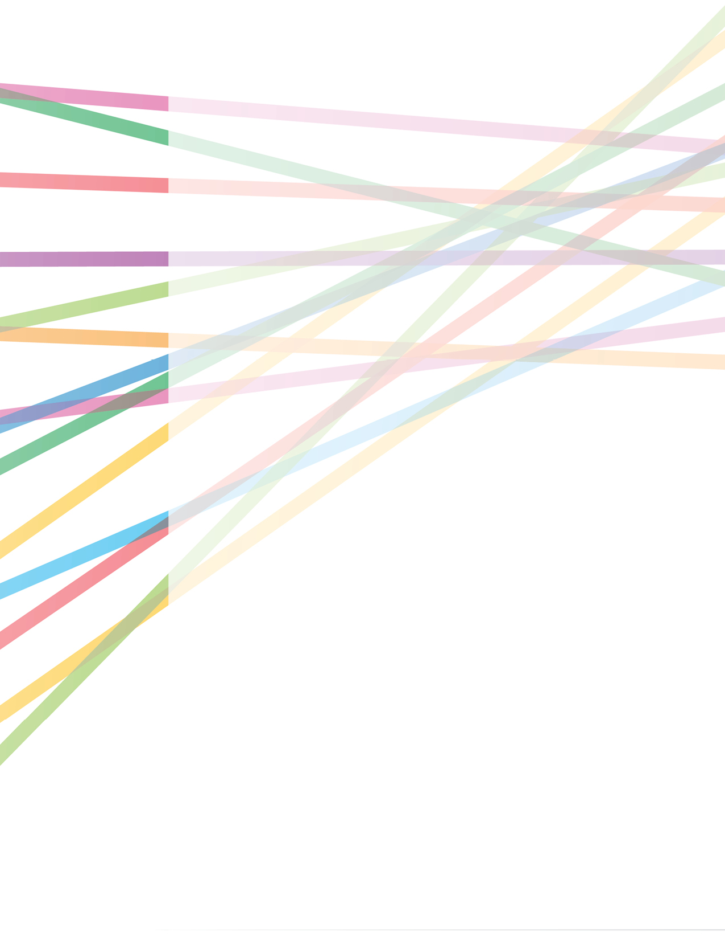
NEW BRUNSWICK - ANGLOPHONE NORTH school district
MENTAL HEALTH AND HIGH SCHOOL CURRICULUM Guide
Evaluation of the Guide Training Program in Anglophone North School District, New Brunswick
Dr. Yifeng Wei, John B. Fletcher, Rebecca Alaffe, Andrew Baxter
February 2021

Background
The Mental Health & High School Curriculum Guide (the Guide) was developed in 2007 by Dr. Stan Kutcher, Sun Life Chair in Adolescent Mental Health in collaboration with the Canadian Mental Health Association. The second and most current edition was prepared in 2014. This resource is compliant with Provincial/Territorial curriculum and was designed to be integrated into Grade 9 or 10 classrooms by the regular classroom teacher who has ideally been introduced to the resource and its pedagogical application during a professional development session. In contrast to stand-alone mental health or anti-stigma programs, this novel approach strives to improve mental health literacy (understanding how to optimize and maintain good mental health; understanding mental disorders and their treatments; decreasing stigma; enhancing help-seeking efficacy) in students and teachers alike; utilizing familiar, education system-compatible, sustainable and inexpensive pedagogic processes by supporting the integration of the resource into existing secondary school curricula. Substantive research has demonstrated highly positive impacts of this approach on all aspects of mental health literacy (Kutcher, Wei, Gilberds, et al., 2016; 2017; Wei, Kutcher, 2015; Milin et al., 2016).
This approach was designed to be easily integrated into existing education and health systems, and its successful global application attests to the value of this delivery method. This is not a program parachuted into a school or school system, it is a human resource capacity-enhancing intervention designed to be sustainable and frugally applied. All materials are freely available on-line where they can easily be accessed by educators, health care providers, students, and parents alike.
For recent publications in scientific journals related to these interventions see the reference list at the end of this report. Evaluations of previous training programs can be found at: http://teenmentalhealth.org/toolbox/?filter_category-filter=school-mental-health-reports
This report is an evaluation of The Mental Health and High School Curriculum Guide described above undertaken in New Brunswick, comprising of two schools from the Anglophone North School District in Miramichi. The Guide sessions took place between September and December 2019. This study was conducted on students in grades 7 and 8 with the aim of testing the affects of The Guide resource on a younger cohort of students from who the resource was originally developed for.
Participants
Sixty-seven students (28 males, 41 females) in grades seven and eight participated in The Guide program. 37 of these students were placed in the experimental group and 30 were in the control group. Of the total participants, all 67 completed both pre- and post-session knowledge and attitudes surveys, while 66 fully completed both pre- and post-test help-seeking surveys. These students were from two schools in the Anglophone North School District [Eleanor W. Graham middle school (experimental group), located in Rexton, and South Esk Regional Middle School (control group), located in Sunny Corner] in New Brunswick. Both schools volunteered to participate in the study.
Procedure
Participants completed anonymous surveys comprised of three sections before and directly following the session: a mental health knowledge survey, an attitude toward mental illness survey (stigma), and a help-seeking attitudes survey. Mental health knowledge was measured with 30 true-false questions, and students were asked to choose either ‘true’, false’ or ‘do not know’. Each correct answer received one point for a maximum total score of 30. To reduce false-correct results, students were encouraged to choose ‘do not know’ rather than guessing at unknown questions, and ’do not know’ choices were scored as incorrect.
Twelve 7-point Likert scale questions were included to assess attitudes toward mental illness. Answer points ranged from ‘Strongly Agree’ to ‘Strongly Disagree’ for a maximum total score of 84 points with higher scores reflecting positive attitudes toward mental illness. Additionally, five 7-point Likert scale questions were included to assess students’ attitudes toward seeking help for mental health concerns. Answer points ranged from ‘Strongly Agree’ to ‘Strongly Disagree’ for a maximum total score of 35 points with higher scores reflecting more positive attitudes toward seeking help for mental health issues or mental illness.
Completed survey responses were entered into a secure database by a researcher blind to participant identities and naïve to the workshop materials and delivery. To assure anonymity, participants were asked to not provide any personal identifying information, and were asked anonymous linking questions to match pre- and post-session data. Linking questions included participants’ birth month, first two letters of their first name, the last two digits of the participants’ phone numbers, and the last three letters of their birth city. Follow-up surveys were to be completed three months after the program (March 2020) to assess retention of mental health information learned. However, due to the COVID-19 pandemic, this failed to happen.
Data were analyzed using the Statistical Package for the Social Sciences (SPSS). Mental health scores, attitudes toward mental illness scores, and attitudes toward help-seeking scores were compared between pre- and post-session surveys using paired-samples t-tests. ANCOVA were conducted in order to measure differences in pre-test to post-test scores between the two groups (experimental and control), using the pre-survey means as covariates. All p-values were compared to a statistical significance alpha of .05, all d-values were compared to Cohen’s d effects scale (.2 = small, .5 = medium, .8 = large), and all h_{p}² values were compared using partial eta squared effects scale (.01 = small, .09 = medium, .25 = large).
Outcomes
Independent t-Test for Control vs. Experimental
Analyses were conducted to study differences between the two groups (control vs. experimental). Pre-test surveys of mental health knowledge showed that participants in the control group started out with an average knowledge score of 10.60 (SD=4.95) out of 30 (35.33% correct), while participants in the experimental group averaged 10.86 (SD=4.55) out of 30 (36.20% correct). This produced an unsignificant result t(65) = -.228, p=.820 (see Figure 1). During the post-session survey, control group participants slightly increased their average to 11.27 (SD=5.07) out of 30 (37.57% correct), while the experimental group statistically significantly increased their average scores to 16.46 (SD=4.86) out of 30 (54.87% correct) after exposure to the Guide t(65) = -4.264, p=.000; d=1.05 (large effect size) (see Figure 1).
Figure 1
Statistical evaluation of
pre-test attitude scores also revealed unsignificant differences between the control group (M=61.33; SD=10.72) and the experimental group (M=66.27; SD=11.79) t(65) = -1.775, p=.081, showing relatively similar attitudes at baseline between two groups (see Figure 2). Average post-test attitude scores were, however, statistically significantly different between the control group (M=61.10; SD=10.20) and experimental group (M=67.45; SD=11.29) out of 84 after completing the program t(65) = -4.784, p=.000, d=.59 (medium effect size) (see Figure 2).
Figure 2
Statistical evaluation of the pre-session average help-seeking scores between the control group (M=25.70; SD=5.81) and the experimental group (M=28.76; SD=4.63) revealed a significant result t(65) = -2.397, p=.019, d=.66 (medium effect size), suggesting a difference in pre-test scores between the two groups (see Figure 3). Post-session scores also revealed a statistically significant difference between the groups t(64) = -2.521, p=.014, d=.62 (medium effect size) (see Figure 3). The average post-session score for the control group was 26.00 (SD= 5.37) out of 35 and for the experimental group was 29.16 (SD= 4.81) out of a possible 35 questions (see Figure 3).
Figure 3
Paired-Samples t-Test for Experimental Group Only
Paired-samples t-tests were also conducted on the experimental group participants, separate from the control group participants, to see if there were any differences in average knowledge, attitudes, and help-seeking scores between pre-session and post-session. Results were more promising with the experimental group. Knowledge scores at pre-session averaged 10.86 (SD=4.55) and increased significantly and substantively to 16.46 (SD=4.86) t(36) = -7.723, p=.000, d=1.19 (large effects size) (see Figure 1). Average attitude scores also increased significantly and substantively from 66.27 (SD=11.79) at pre-session to 72.59 (SD=9.43) at post-session t(36) = -7.723, p=.000, d=0.59 (medium effect size) (see Figure 2). Alternatively, average help-seeking scores did not increase statistically significantly, despite the slight numerical increase from 28.76 (SD=4.63) at pre-session to 29.16 (SD=4.81) at post-session t(36) = -.616, p=.542 (see Figure 3). These help-seeking average scores may not be significantly different between pre-session and post-session because of the already high numbers at pre-session, indicating a ceiling effect.
Analysis of Covariance for Group by Gender at Post-Test
Three two-way Analyses of Covariance (ANCOVA) were conducted using pre-test scores as the covariate and post-test scores as the dependent variable in order to study the differences in average post-test knowledge, attitude, and help-seeking scores between males and females within the control group and the experimental group whilst controlling for pre-test scores. The ANCOVA for knowledge resulted in a significant interaction in group by gender F(1,61) = 4.012, p< .05, h_{p}² = .062 (small effect size). This indicates that there is an interaction between group and gender for knowledge scores. The main effects were found between the control group and experimental group F(1,61) = 27.740, p < .001, h_{p}² = .313, not between males and females F(1, 61) = .003, p = .955.
The two-way ANCOVA for attitudes did not reveal a significant interaction in group by gender controlling for pre-test scores F(1,61) = .240, p = .626. This also indicates that there is no interaction between gender and group. However, main effects show that there are significant differences for mean attitude scores between male and female participants F(1,61) = 4.109, p <.05, h_{p}² = .063 and between the experimental and control groups F(1,61) = 19.138, p <.001, h_{p}² = .239. Female students performed significantly better in both control (M=62.73, SD=9.57) and the experimental group (M=74.46, SD=7.45) than male students (M=59.47, SD=10.87) in the control and experimental group (M=68.92, SD=12.35), although male students improved their attitudes at post-test. The ANCOVA for help-seeking did not reveal statistically significant interaction results for gender by group F(1,60) = .467, p = .497. Main effects analyses also showed no differences between genders F(1,60) = .939, p =.336, nor between groups F(1,60) = 1.800, p = .185.
Qualitative Analysis
Two questions were asked of students to assess their views on whether this resource would be beneficial for younger students. These questions were open-ended, allowing for the students to answer truthfully and say as much as they’d like about each topic. All 37 students who participated in the experimental group answered the two questions. An overwhelming majority of students expressed enthusiasm and appreciation for the content of this curriculum. Most stated that they think the topics discussed were important for youth to learn in middle school.
The first question was “Do you think learning about mental health in middle school is important? Please explain in detail why or why not.” Participants identified the importance of learning mental health in six areas. The six key categories that emerged when in discussion with the students are: help-seeking, stigma, preparing for the future, learning when young, brain development/science, and literacy. They considered getting appropriate help or help-seeking as the most important benefit. Nineteen students stated that they felt they can get the right help for themselves, friends and family. The students stated they felt more knowledgeable on the signs of mental distress and disorders and felt more comfortable seeking help for themselves or a classmate, as needed. One student said “Learning mental health in middle school is really important because what if we have these things and we don’t know what to do. Learning this can help a lot of kids.”
Ten students believed that stigma reduction was very important and learning this in middle school will help normalize mental illnesses and help understand people, and their differences better. An example of this that a student gave: “Yes, I think learning about mental health is important because you don’t want to treat someone with a mental health disorder differently than everyone else.”
Eight students felt that they will benefit from knowing this information in the future as they may deal with people in their lives who have mental illnesses and the students feel like they could help them. Or they themselves may develop a mental illness as they grow up and they will be equipped on how to deal with it in their own lives. A student stated that they think it is important to gain this knowledge because “it will help avoid injury and deaths of teenagers so they will get a better future with no harms and big troubles in their own life.”
Four students felt that learning at a younger age is easier and, therefore, you can learn more information more efficiently. One student will take this information with them for the rest of their lives to be used in pertinent situations, “Yes I think that learning about mental Health in middle school is important because It’s easier to learn things from the ages 11 and 12. So learning about this can help us prepare for when we get older and can help us in stressful situations.” Students find this information beneficial to learn in middle school, while they are younger, so they can be better equipped with the tools and resources needed to reduce stigma and to help themselves and others as needed in the future.
Two students liked the idea of learning about the science of the developing teenage brain. Students exposed to The Guide resource learn about the “normal” development of the brain and behaviour of a middle schooler, and therefore, any specific neurological abnormalities that students may be currently dealing with or soon will deal with. One student said, “Yes, I do think it is important because the teen brain is still developing. It's good to know that there is help that you can get (treatment) and it’s good to know the information.” Learning about the developing teenage brain is also good at this age so that students will know what is actually normal for most people their age, even if it seems distressing to them at the time.
One student discussed all components of mental health literacy and has a really good understanding of the importance of a well-rounded mental health literacy resource. The student stated, “I think learning about mental health in middle school is important because I hear a lot of people in my school say, “I’m so depressed,” when they are really not. And some kids these days feel lonely like they have no one to talk to, so informing kids about mental health at a young age is good. Seeing as there is a lot of stigma on the topic it also helps to talk about stigma so that those youth with a mental illness don’t feel excluded”. This might indicate that The Guide resource can be successful in helping grade seven and eight students hone in on what these topics really mean to them individually, since the outcomes will vary between each student.
The second question included in this survey was “What part of the mental health curriculum did you find most interesting/ important to learn about? Please explain.” Similar to question one, the results from this question were combined into five categories on: specific disorders, getting help, brain science, stigma (especially with personal stories), and mental health literacy.
The biggest response to this question was that the students really learned beneficial information on specific disorders. With 17 students speaking on this, the most popular topic that the middle schoolers enjoyed learning about is Attention-Deficit Hyperactivity Disorder. With the second most popular being Anxiety and its associated disorders, such as Obsessive-Compulsive Disorder. The warning signs of suicide seems to be important to some students, “The signs of teen suicide. If a friend or relative is looking to die you can see that and help.”
Seven students really enjoyed learning about how and when to get help for mental distress or mental disorders. One student was comforted knowing that people care about them when they seek help. “I think the most important topic we learned about is asking for help. Because it really encourages people to be concerned and realize that there are people that care out there.” Others stated that they can encourage others to seek the help they need, with no judgement. One student said that seeking help is always a good idea, “The most important thing that I learned about mental health is to always seek for help even though you’re scared and worried. Because it’s not always right to keep your problems to yourself.”
Brain development and brain function was important to six students. One student particularly found this most interesting: “how our body reacts to certain things. Like how we can sense danger, or how we have neurons connecting through our body and communicating.” Five students stated that they think reduction of stigma was the most important part to learn from the curriculum. Everything from the effects of stigma, reducing their own stigma (“The part when we learned about all of the mental disorders and learn that people with mental disorders are almost just like us”). As well as how stigma can lead to a reduction in help-seeking and furthers their understanding of how important seeking help is, “The most important thing I learned about in the mental health curriculum is stigma because now we know what keeps people from getting help, so we can encourage them to get help.”
Including first-hand accounts of people with mental illnesses and how they go about their lives jumping past each hurdle has been beneficial for many students. These students liked the videos about the personal stories and how they deal with their illness every day and how they are recovering. It shows the students different perspectives, “I also like in the videos we watched we can see that person with a disorder, their view in this world.” Some students also felt connected to the personal stories with their own experiences, “The most important part of the mental health curriculum was about all the disorders and the things that many people go through. Another thing is how they can recover and what affects them the most during what they are going through. Recovery is one of the toughest things to go through, I just handled with my anxiety, and went to see a professional about my anger issues.” Having the videos of actual people, with actual true stories gave a more powerful way of learning about others and what they are going through for some students, “I think learning about different people with different disorders was really cool to see. It was almost like talking to them in person, except they were the only ones talking. I liked learning their stories and how they got help.”
Some aspects of mental health literacy were important to a couple of students. Learning the difference between mental health and mental illness as well as the statistics of each mental illness and onset age were among the top interests of these students.
Overall, the evaluations indicated a predominantly positive experience with the program in addition to the previously detailed positive statistical outcomes on mental health knowledge, attitudes toward mental illness, and help-seeking. This offers further support for the implementation of this training with educators in the province of New Brunswick.
Discussion
The results of this evaluation clearly demonstrate the benefits of the Mental Health and High School Curriculum Guide program for students’ general knowledge about mental health and mental illness, and attitudes toward mental illness and help-seeking. Both knowledge and attitude scores showed statistically significant (p=.000; p=.003, respectively) as well as statistically substantial (d=.66; d =.30, respectively) improvements following the intervention in the experimental group.
Results from the gender analyses showed non-significant differences in average knowledge and help-seeking scores (p=.484; p=.221, respectively). However, there were significant differences in attitudes scores, with women showing higher average attitude scores (p = .019, h_{p}² =.084). This may suggest that females have better attitudes toward mental illness than males, while gender didn’t play an important role for the change of knowledge and help-seeking intentions.
This evaluation illustrates the significant positive changes in the enhancement of Anglophone North School District students’ knowledge and attitudes toward mental illness achieved using an educationally appropriate and inexpensive classroom-ready, student-focused mental health literary enhancement intervention that draws on existing pedagogical expertise. This result is consistent with evaluations conducted in high schools in other Canadian provinces (Kutcher, Wei, & Morgan, 2015; McLuckie, Kutcher, Wei, & Weaver, 2014; Kutcher & Wei, 2013; Kutcher, Bagnell, & Wei, 2015; Wei, Kutcher, Hine, & Mackay, 2014, see http://teenmentalhealth.org/toolbox/ ?filter_category-filter=school-mental-health-reports for School of Mental Health reports from Nova Scotia, Ontario, and Calgary, Alberta) and further demonstrates the suitability of this approach as an effective intervention that can be used to improve mental health literacy of middle school students in Anglophone North School District in New Brunswick, and potentially across the province.
Unfortunately, the planned follow-up test scheduled for March 2020 had to be cancelled due to the COVID-19 pandemic. This follow-up test could have supported previous findings that the Guide resource has a lasting effect on students’ knowledge and attitudes toward mental health and mental illness.
The qualitative data seem to indicate that a lot of the students have compassion for others and they wish not to do harm to other students and adults, currently and in their future. Much of the stigma and negative connotation surrounding mental illnesses can come from a lack of education on the topic and compassion of other people’s experiences in life. An interesting aspect to add to future study would be to see if students’ level of compassion for others increases due to exposure to this mental health literacy resource, and whether stigma is linked to compassion. In addition, the fact that many students enjoyed learning about specific mental disorders argued against previous perspective that such education about mental disorders will aggravate the effect of stigma against mental illness (Pescosolido, 2016). This may be because young people are more prone to learn new information and form positive attitudes towards mental health. This represents a new opportunity for researchers and practitioners in this area.
The results presented in this report suggest that the application of this intervention (the Mental Health & High School Curriculum Guide resource) would be a useful and important component to school mental health education in the Anglophone North School District, as well as the province of New Brunswick. Thus, providing an effective approach to mental health literacy in New Brunswick schools has the potential to benefit students and enhance the link between education and health to address student mental health needs, using evidence-based approaches in a systematic and collaborative manner.
References
Kutcher, S., Bagnell, A. & Wei, Y. (2015). Mental health literacy in secondary schools: A Canadian Approach. Child and Adolescent Psychiatric Clinics of North America, 24(2), 233-244. Doi: 10.1016/j.chc.2014.11.007
Kutcher, S., & Wei, Y. (2013). Challenges and solutions in the implementation of the school-based pathway to care model: the lessons from Nova Scotia and beyond. Canadian. Journal of School Psychology 28, 90–102.
Kutcher, S. & Wei, Y. (2014). School mental health literacy: A national curriculum guide shows promising results. Education Canada, 54, 22-26. http://www.cea-ace.ca/education-canada/article/school-mental-health-literacy
Kutcher, S., Wei, Y., Gilberds, H., Brown, A., Ubuguyu, O., Njau, T., Sabuni, N., Magimba, A., & Perkins, K. (2016). A School Mental Health Literacy Curriculum Resource Training Approach: Effects on Tanzanian Teachers’ Mental Health Knowledge, Stigma and Help-seeking Efficacy. International Journal of Mental Health Systems 10(50). DOI: 10.1186/s13033-016-0082-6
Kutcher, S., Wei, Y., Gilberds, H., Brown, A., Ubuguyu, O., Njau, T., Sabuni, N., Magimba, A., & Perkins, K. (2017). The African Guide: One Year Impact and Outcomes from the Implementation of a School Mental Health Literacy Curriculum Resource in Tanzania. Journal of Education and Training Studies, 5(4), 64-73. DOI:10.11114/jets.v5i4.2049
Kutcher, S., Wei, Y., Gilberds, G., Brown, A., Ubuguyu, O., Njau, T., Sabuni, N., Magimba, A., & Perkins, K. (2016). Community Helath Care Providers Knowledge and Self-confidence in the Identification, Diagnosis and Treatment of Adolescent Depression in Tanzania. Arch Depress Anxiety, 2 (1), 26-30.
Kutcher, S., Wei, Y., & Hashish, M. (2016). Mental Health Literacy for Students and Teachers: A “School Friendly” Approach. In M. Hodes (Ed), Positive Mental Health for Children and Adolescents.
Kutcher, S., Wei, Y. & Morgan, C. (2015): Successful application of a Canadian mental health curriculum resource by usual classroom teachers in significantly and sustainably improving student mental health literacy, Canadian Journal of Psychiatry, 60(12), 580-586. DOI 10.1177/070674371506001209
McLuckie, A., Kutcher, S., Wei, Y. & Weaver, C. (2014). Sustained improvements in students’ mental health literacy with use of a mental health curriculum in Canadian schools. BMC Psychiatry, 14(379). DOI 10.1186/s12888-014-0379-4
Milin, R., Kutcher, S., Lewis, S., Walker, S., Wei, Y., Ferrill, N., & Armstrong, M. (2016). Impact of a mental health curriculum on knowledge and stigma among high school students: a randomized controlled trial. Journal of American Academy of Child and Adolescent Psychiatry 55(5), 383-391. DOI: 10.1016/j.jaac.2016.02.018
Pescosolido, B.A. (2016). The beginning of the end? Deploying rigorous research in real-world settings to reduce stigma. Journal of American Academy of Child and Adolescent Psychiatry 55(5), 353-354. DOI:https://doi.org/10.1016/j.jaac.2016.03.001.
Wei, Y. & Kutcher, S. (2015). International School Mental Health: Global Lessons. In S. Kutcher, Y. Wei, & M.D. Weist (Eds.), School Mental Health: Global Challenges and Opportunities. Cambridge: Cambridge University Press.
Wei, Y., Kutcher, S., Blackwood, A., Glover, D., Weaver, C., MacKay, A., Bruce, V., Whynacht, A., Alshazly, F., & Shea, M. (2015). A collaborative and sustainable approach to address mental health promotion and early identification in schools in the Canadian province of Nova Scotia and beyond. In S. Kutcher, Y. Wei, & M.D. Weist (Eds.), School Mental Health: Global Challenges and Opportunities. Cambridge: Cambridge University Press.
Wei, Y., Kutcher, S., Hine, H. & Mackay, A. (2014). Successfully embedding mental health literacy into Canadian classroom curriculum by building on existing educator competencies and school structures: The Mental Health and High School Curriculum Guide for secondary schools in Nova Scotia. Literacy Information and Computer Education Journal,5(3), 1158-1163.

